Prismatic TTRPG – Early Draft
***Disclaimer: All AI or Stock Photo Art is purely used in the sense of having some sort of mood board and imagery to break apart the text, and will be phased out***

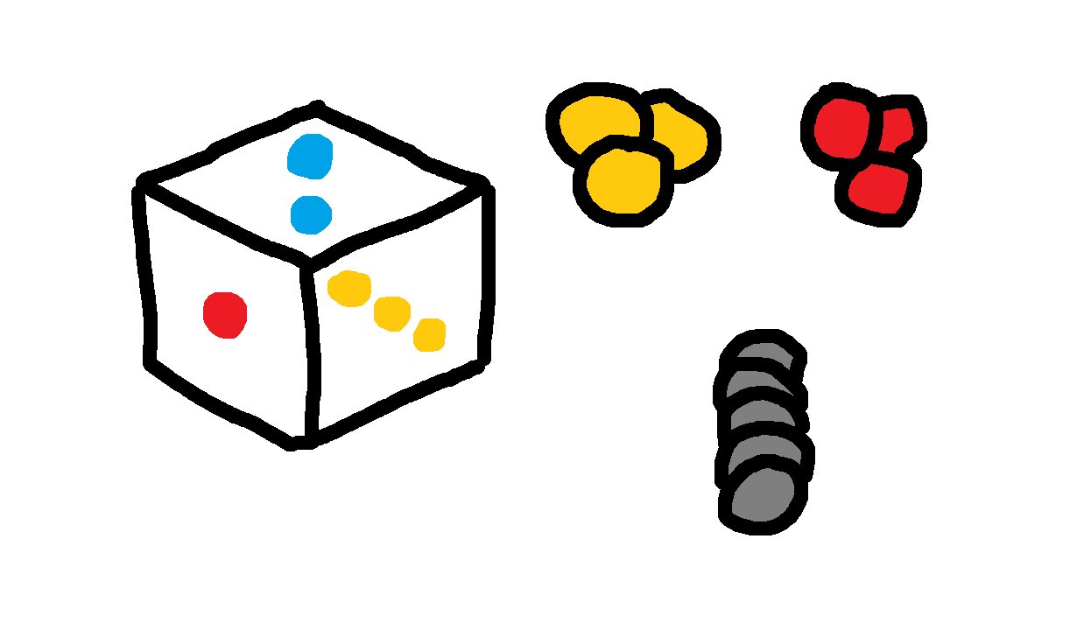
Playing the Game

Character Statistics
In the world of Prima, no two Channelers approach the world the same way.
A barbarian full of vigor and a mage slinging spells through sheer willpower may stand side by side on the same battlefield — but the traits that define them, and the Prisma that flows through them, couldn't be more different.
These traits are divided into six Facets, split across two axes of self:
MIND is an abstract, internal representation of self — the self that is projected outward into the world, often conflated with personality, intelligence, and charisma. Mind takes up space in the theoretical sense.
MATTER is a material, external representation of self — the self that exists within the world, often conflated with constitution, strength, and physical dexterity. Matter takes up space in the literal sense.
Within each axis, your Facets are further divided into three expressions: how you exert force upon the world, how you build and shape it, and how you endure within it — your Force, your Artifice, and your Body.

MIND
Willpower (WIL)
Willpower represents the Force of MIND. This is the power through which one projects self into the world. A mind with high willpower desires to actively write their will into reality, powering through obstacles if necessary.
Willpower presents itself as passion, fiery ambition, unapologetic authenticity, and a single-minded drive to accomplish a goal.
Wit (WIT)
Wit represents the Artifice of MIND. This is the skill and craftsmanship through which one shapes the world. A mind with high wit is adaptive and innovative, deftly maneuvering around situations before they become obstacles.
Wit presents itself as intelligence, creativity, charisma, and an infinite toolbox of ways to approach any problem.
Resolve (RES)
Resolve represents the Body of MIND. This is the resilience and focus through which one endures the world. A mind with high resolve strives for the focus and sense of self to endure within the world, weathering through any challenges that come their way.
Resolve presents itself as discipline, fortitude, wisdom, and unshakable resilience through any circumstance.

MATTER
Athleticism (ATH)
Athleticism represents the Force of MATTER. A body with high athleticism can overpower others and handle intense physical challenges that come its way. A composite of speed, power, and forceful strength.
Governs standard martial weaponry and raw combat force.

Aptitude (APT)
Aptitude represents the Artifice of MATTER. Precise, skilled physical execution.

Robustness (ROB)
Robustness represents the Body of MATTER. A body with high Robustness takes up space and absorbs blows without issue. A composite of endurance, hardiness, and functional strength.
Governs brawler combat, physical endurance, and the body as a weapon.

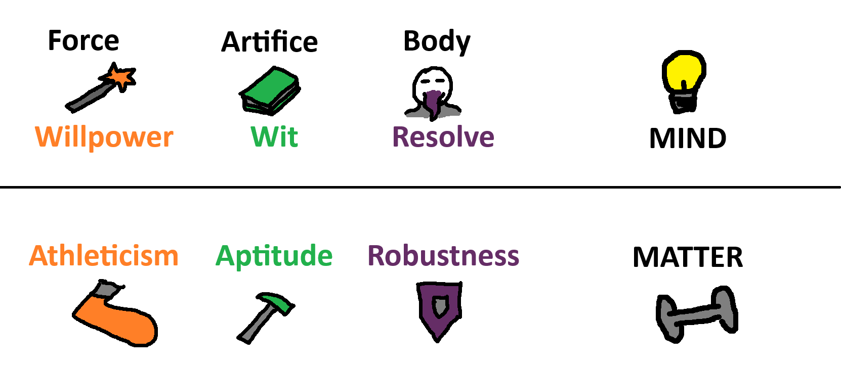

Basic Vocabulary
Prima – Raw, neutral energy and magical substrate. Originates in the cosmos and exists in all things (including the body and soul). Pearlescent, plasma-like and not directly tangible.
Prisma – Prima altered by intent and bias. Takes on a different visible color, form, and function depending on the nature of this intent. Falls into several different categories that are channeled for different purposes.
Staining – The process of changing Prima into Prisma, whether intentional or unintentional. Can be done through physical (tangible environment) or metaphysical (personality, culture, mood) interactions.
Inkling (“Pip”) – Unit of Prisma. Represented by a Translucent Disc on the table or a single “pip” on a sheet.
Transient Prisma (“Temp Prisma”) – An Inkling of unstable, ad-hoc “Use it or Lose it” Prisma that disperses after a single round of combat.
Fingerprint – The soul’s Unique Prismatic Signature, measured in fifths and represented on an Emblem. Determines pips generation distribution.
Channeling – The art of manipulating Prisma. Most commonly encompasses spellcasting, artifice, alchemy, staining, storage and transport.
Channeler – One who pursues Prismatic Understanding
Attunement – The specific archetype or path that a Channeler chooses to walk. A general categorization of specialization, abilities, and skillset.
Conduit – Prima Conductor used to attract and direct the flow of Prima. Most commonly seen in the form of dense plant fiber, thin bones, and synthetics. The most potent and sought-after Conduits come from the Cosmos in the form of meteorite metal.
Ward – One-way Prima Insulator used to collect and store Prima for periods of time. Most commonly seen in the form of Amber, skulls, and synthetics. The most potent and sought-after Wards come from the Cosmos in the form of meteorite glass.
Battery – An orb of Ward material used to portably store Prima to be used by Channelers. Explosion risk if damaged.
Lens – Small disk of refined glass used to manually stain Prima into Prisma.

Prisma Domains
Lower-Order – Considered the most fundamental and crude categories of Prisma. These include Entropic (Red) Prisma, Fabric (Blue) Prisma, and Morphic (Yellow) Prisma. Most Fingerprints consist solely of Lower-Order colors. Lower-Order Prisma is very common and easy to come by in the world.
Higher-Order – Considered to be composite, advanced categories of Prisma. These include Animated (Orange), Fortified (Green) and Invigorated (Purple) Prisma. Fingerprints can become stained Higher-Order colors upon a deeper understanding and study of channeling them – learning to see them as their own rather than composites of Lower-Order Colors. Higher-Order Prisma is rarer in the world and seen where lower-order environments overlap
Special-Order – Abstract domains with very specific, complex color profiles (Hexus, Vitus, Enchantus, Kinetus, etc.) Requires a deep, high-level understanding of Prisma and the self to properly channel. Very uncommon and found in very small pockets in the natural world.

